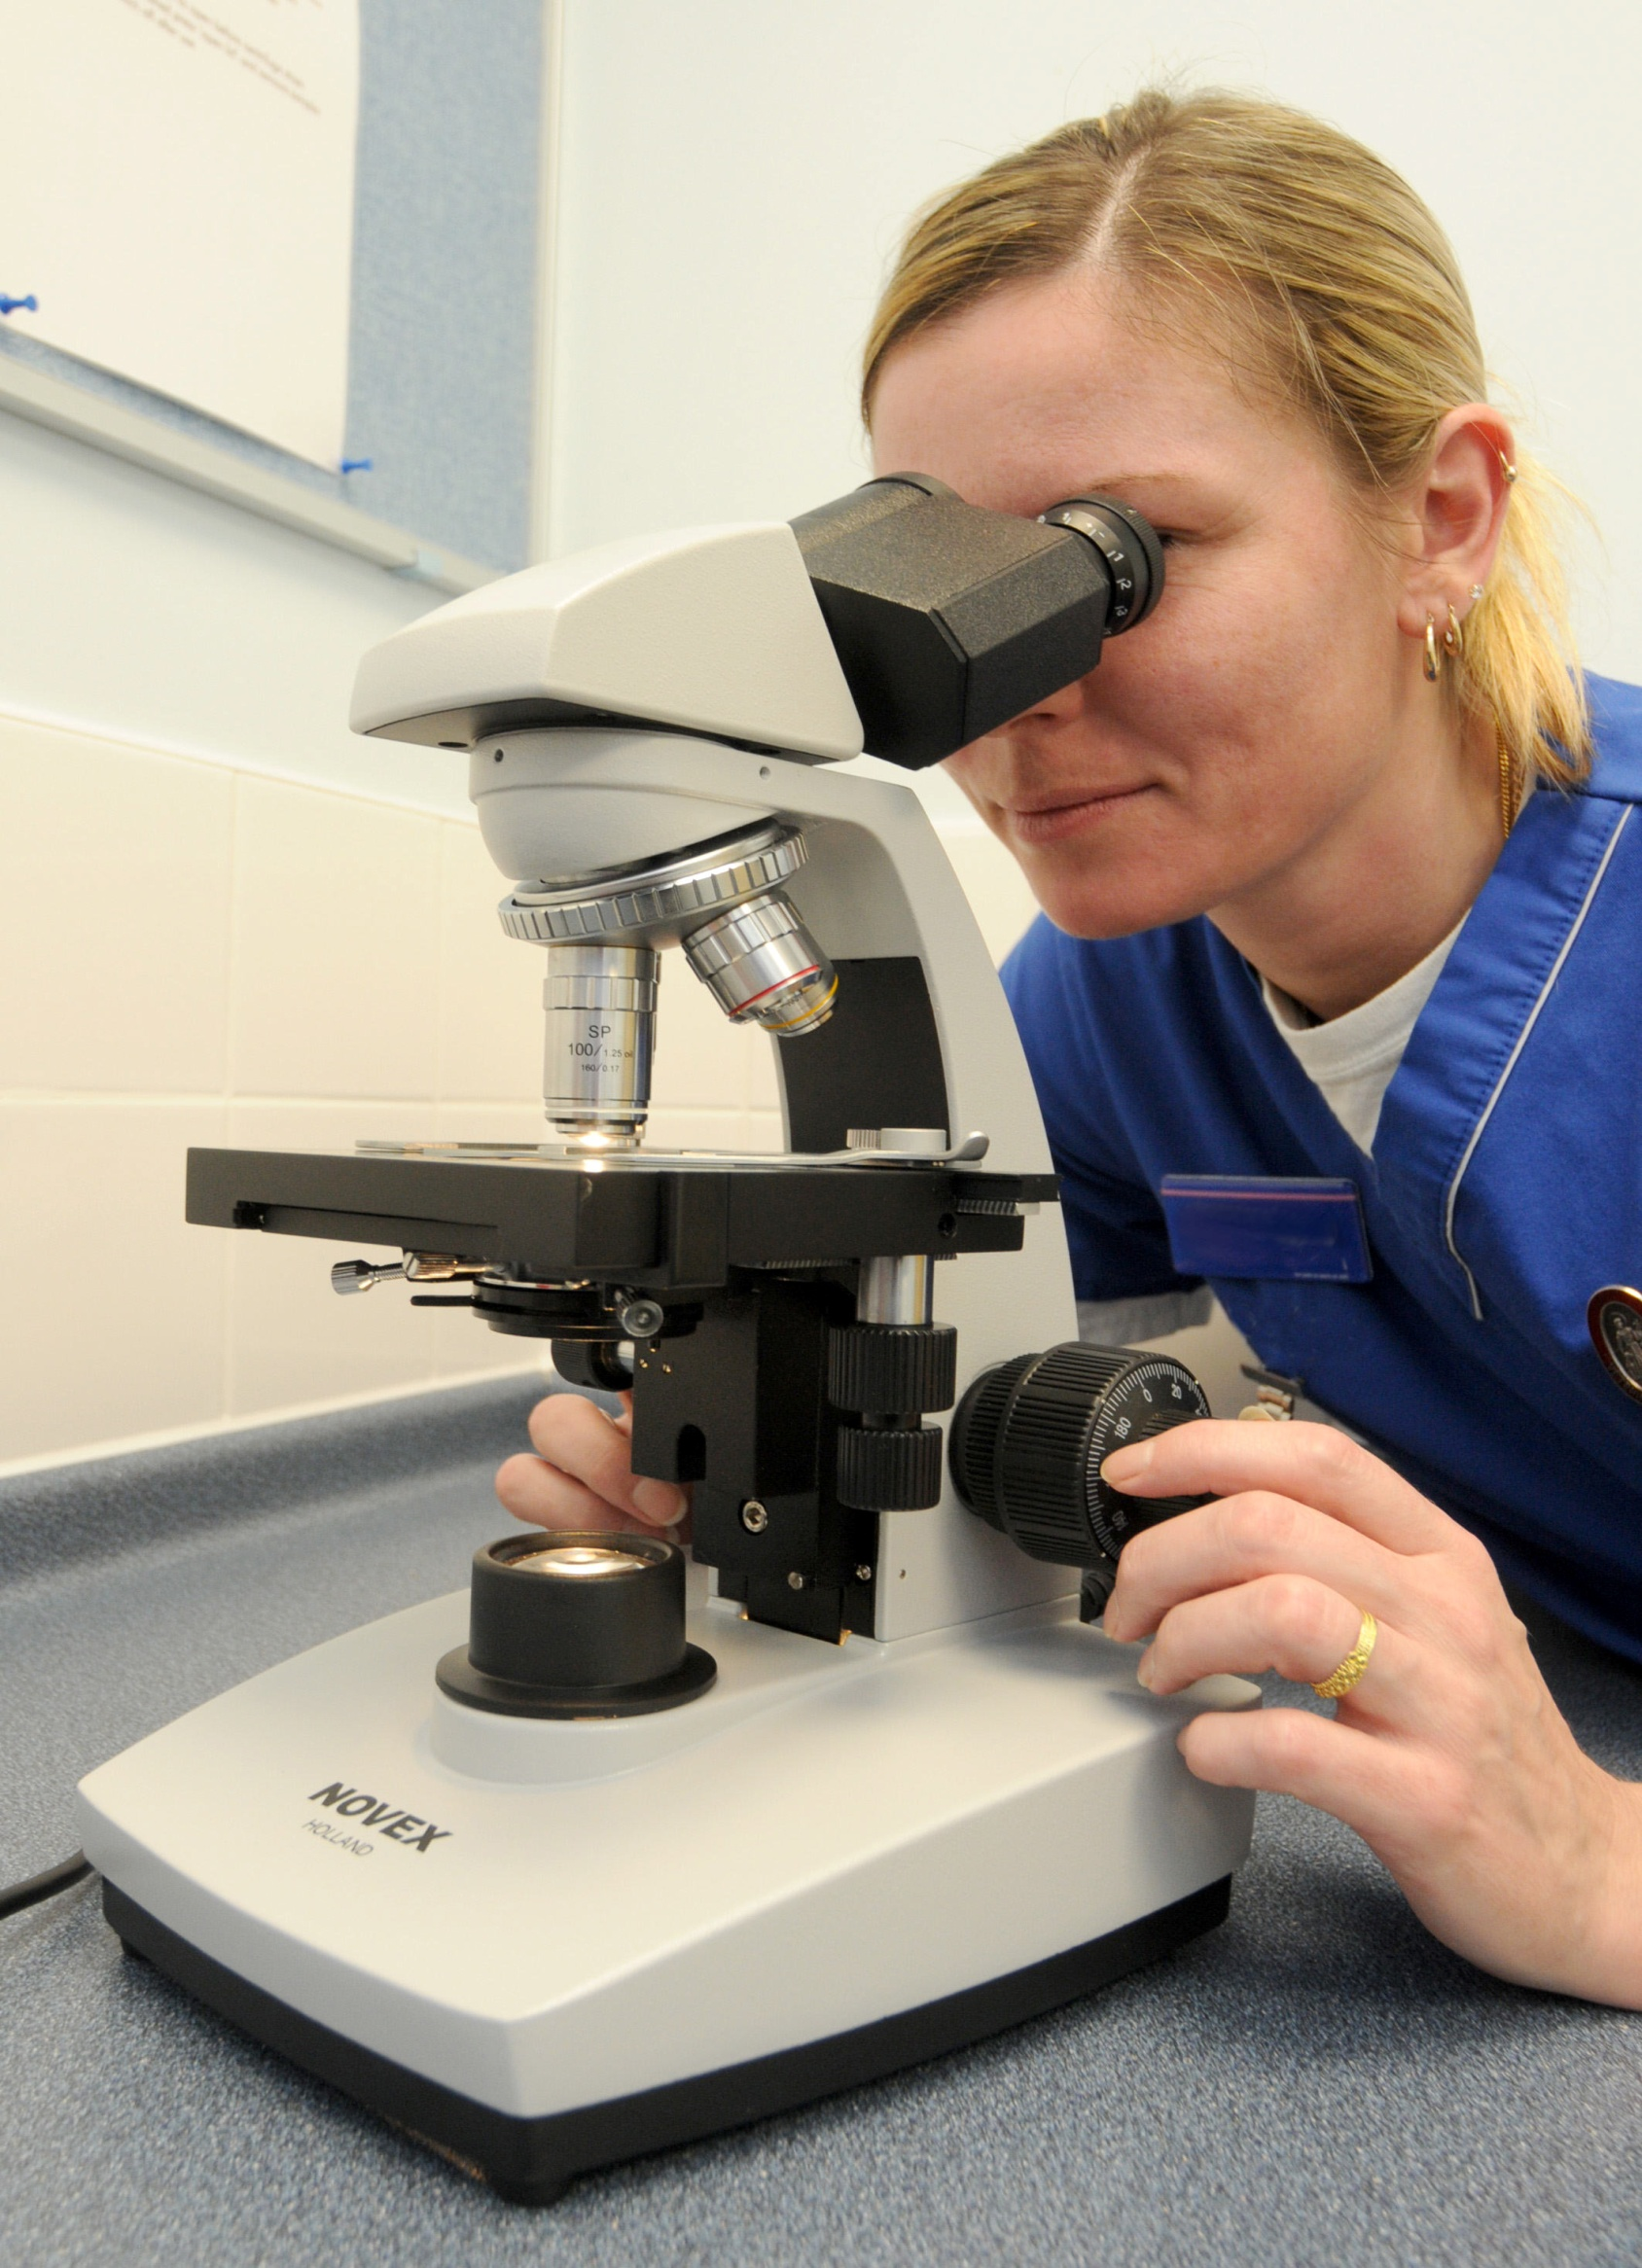
9th Annual R&D Conference
Research – Access All Areas

Reserve your place now!

Tuesday 19th June 2018
09:30 – 16:00

To be held at the

Christchurch Centre, Old Malpas Road, Newport, NP20 5PP

This is a Free Event

Confirmed Speakers:

Keynote Speaker –
Dr Alan Parker, Senior Lecturer, Cardiff School of Medicine

Dr Stuart Linton, Consultant Rheumatologist, ABUHB
Dr Jonathan Hewitt, Senior Lecturer and Consultant, NHS
Dr Girish Patel, Consultant Dermatologist
Dr Huw Williams, General Practitioner and Clinical Lecturer

Closure of Conference: Cwmbran Deaf Choir

Further information is available from:

Jane Jones on 01633 238967 Jane.Jones14@wales.nhs.uk
Alison Davey on 01633 234768 Alison.Davey@wales.nhs.uk
or ABB.RandD@wales.nhs.uk

