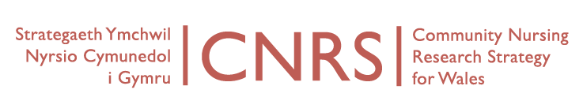
Wednesday, 14th October, 10-12
Board Meeting
Venue: University of South Wales, Aneurin Bevan Building, Room AB115, Lower Glyn Taf Campus, Pontypridd CF37 1DL.
Directions: http://findaroom.southwales.ac.uk/rooms/gtab115
Video conferencing IP address: 194.83.178.242
AGENDA
Attending:
Teleconference: Joanne Pike (Glyndwr, tel: 01978 293596)
Apologies: Sue Bale (AB), Rhiannon Beaumont Wood (PHW), Jane Imperato (C&V), Neil James (USW), Adrian Jones (BC UHB), Marie Lewis (Powys tHB), Ruth Northway (USW), Debbie Roberts (Glyndwr), Tanya Spriggs (ABM ULHB), Sue Thomas (USW), Caroline Williams (Hywel Dda UHB)
- Welcome and Introductions (Apologies)
- Notes of last meeting held 29th April 2015
- Matters arising
- Framework for collaboration
- Report on Coordinator activity this quarter (CW)
- Marketing
- CNRS updates
  - CNRS Portfolio Studies
  - Developing Industry Research
  - Bevan Commission
  - WONCA Dubrovnik / Istanbul / ICCRN conference Seoul
- Future projects or Collaborations
  - Frailty
  - Tender Public Health Wales
- CNRS Research themes and leads:
  - Organisational change and service redesign
  - Nursing roles
  - Skill mix
  - Evidence and outcomes
  - Education and development
  - Long-term care
  - Occupational health
  - Patient safety
  - Patient and user perspectives
- Link with leading areas in new Centre (PRIME Centre Wales / Wales Centre for Primary & Emergency Care Research)
- Next CNRS conference – 2016 (bi-annual)
- AOB
- Dates of next meetings

Related documents
- Previous minutes: 29/04/2015
- CNRS Marketing Full Report & Summary

